**$Customer Usage report**

**$Name Cluster**



Date: MM/dd/YYYY  
Author: Engineer Name  
engineerAddress@crossvale.com

# **Table of Contents**

Cluster Overview

Host Report

Master hosts

Master Services status

etcd status

KubeAPI status

Infra hosts

Infra services

Monitoring Stack Health

Logging Stack Health

Registry Health

Compute host

Workload platform overlook

CPU Graph Usage of last 7 days of each node

$computeName1

$computeName2

$computeName3

MEM Grap Usage of last 7 days

$computeName1

$computeName2

$computeName3

Workload Analysis

Objects Summary

Last week CPU Graph of project Usage

Last Week Mem Graph of project Usage

Storage Analysis

Summary

Summary of PV use cases

Recent problems

Recommendations and remediations

$problemDetected1

$ProblemDetected2

$problemDetected3

# Cluster Overview

|  |  |
| --- | --- |
| Cluster Name | $clusterName |
| Cluster Version | $clusterVersion |
| Total Hosts | $totalHost |
| * Master host | $totalMaster |
| * Infra host | $totalInfra |
| * Compute host | $totalCompute |
| Total projects in cluster | $totalProjects(oc get ns --no-headers | wc -l) |
| Total pods(Running/Other state) | ($runningPods/$otherPods) |
| Total storage classes | $totalSC(oc get sc) |
| Total PVC | $totalPVC(oc get pvc..) |

# Host Report

## Master hosts

|  |  |
| --- | --- |
| Node name: | $masterName1 |
| Node IP: | $masterIP1 |
| Instance Type: | $masterInstance1 |
| Running pods in node: | $runningPodsInMaster1 |
| CPU (Requested/Limit) | $cpuRemLim1 |
| MEM (Requested/Limit) | $memReqLim1 |

|  |  |
| --- | --- |
| Node name: | $masterName2 |
| Node IP: | $masterIP2 |
| Instance Type: | $masterInstance2 |
| Running pods in node: | $runningPodsInMaster2 |
| CPU (Requested/Limit) | $cpuRemLim2 |
| MEM (Requested/Limit) | $memReqLim2 |

|  |  |
| --- | --- |
| Node name: | $masterName3 |
| Node IP: | $masterIP3 |
| Instance Type: | $masterInstance3 |
| Running pods in node: | $runningPodsInMaster3 |
| CPU (Requested/Limit) | $cpuRemLim3 |
| MEM (Requested/Limit) | $memReqLim3 |

### Master Services status

#### etcd status

|  |  |
| --- | --- |
| etcd status | $oc get etcd -o=jsonpath='{range .items[0].status.conditions[?(@.type=="EtcdMembersAvailable")]}{.message}{"\n"}' |

#### KubeAPI status

|  |  |
| --- | --- |
| $apiURL/healthz |  |

## Infra hosts

|  |  |
| --- | --- |
| Node name: | $infraName1 |
| Node IP: | $infraIP1 |
| Instance Type: | $infraInstance1 |
| Running pods in node: | $runningPodsInInfra1 |
| CPU (Requested/Limit) | $cpuRemLimInfra1 |
| MEM (Requested/Limit) | $memReqLimInfra1 |

|  |  |
| --- | --- |
| Node name: | $infraName2 |
| Node IP: | $infraIP2 |
| Instance Type: | $infraInstance2 |
| Running pods in node: | $runningPodsInInfra2 |
| CPU (Requested/Limit) | $cpuRemLimInfra2 |
| MEM (Requested/Limit) | $memReqLimInfra2 |

|  |  |
| --- | --- |
| Node name: | $infraName3 |
| Node IP: | $infraIP3 |
| Instance Type: | $infraInstance3 |
| Running pods in node: | $runningPodsInInfra3 |
| CPU (Requested/Limit) | $cpuRemLimInfra3 |
| MEM (Requested/Limit) | $memReqLimInfra3 |

### Infra services

#### Monitoring Stack Health

##### 

|  |  |
| --- | --- |
| node-exporter running | OK |
| Prometheus | OK |
| Alert Manager | OK |
| Grafana | OK |

#### Logging Stack Health

|  |  |
| --- | --- |
| fluentd running | OK |
| ElasticSearch running and healthy | OK |
| Kibana | OK |

#### Registry Health

|  |  |
| --- | --- |
| Registry Pods running | OK |
| Registry pruning jobs | OK |

## Compute host

|  |  |
| --- | --- |
| Node name: | $computeName1 |
| Node IP: | $computeIP1 |
| Instance Type: | $computeInstance1 |
| Running pods in node: | $runningPodsIncompute1 |
| CPU (Requested/Limit) | $cpuRemLimcompute1 |
| MEM (Requested/Limit) | $memReqLimcompute1 |

## 

|  |  |
| --- | --- |
| Node name: | $computeName2 |
| Node IP: | $computeIP2 |
| Instance Type: | $computeInstance2 |
| Running pods in node: | $runningPodsIncompute2 |
| CPU (Requested/Limit) | $cpuRemLimcompute2 |
| MEM (Requested/Limit) | $memReqLimcompute2 |

## 

|  |  |
| --- | --- |
| Node name: | $computeName3 |
| Node IP: | $computeIP3 |
| Instance Type: | $computeInstance3 |
| Running pods in node: | $runningPodsIncompute3 |
| CPU (Requested/Limit) | $cpuRemLimcompute3 |
| MEM (Requested/Limit) | $memReqLimcompute3 |

### Workload platform overlook

|  |  |
| --- | --- |
| Total pods in compute nodes | $TotalPodsInComputes |
| Running pods | $TotalRunningPodsinComputes |
| Other states(Error,Completed,CrashLoopBackOff..) | $TotalOtherStatePodsInComputes |

### 

### CPU Graph Usage of last 7 days of each node

#### $computeName1

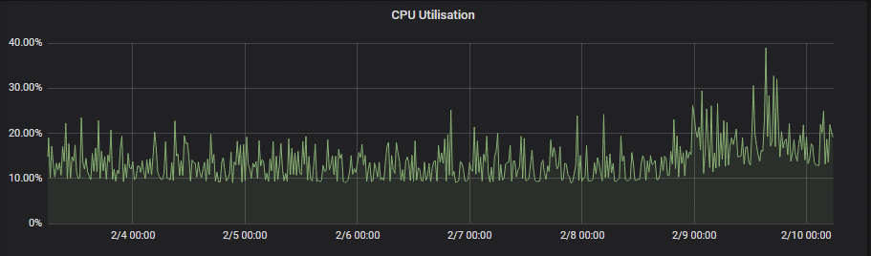

|  |  |
| --- | --- |
| Max Peak CPU Usage |  |
| Min CPU Usage |  |

#### $computeName2

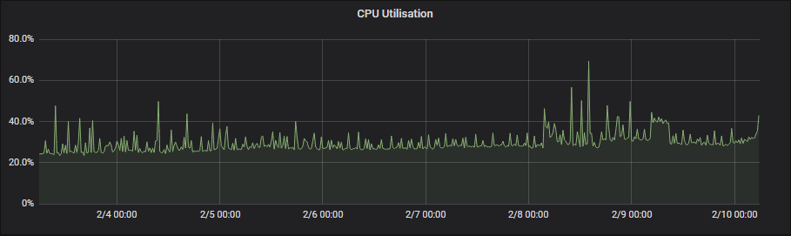

|  |  |
| --- | --- |
| Max Peak CPU Usage |  |
| Min CPU Usage |  |

#### $computeName3

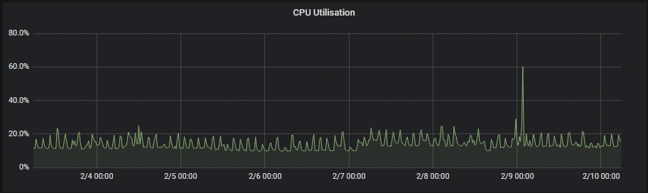

|  |  |
| --- | --- |
| Max Peak CPU Usage |  |
| Min CPU Usage |  |

### MEM Grap Usage of last 7 days

#### $computeName1

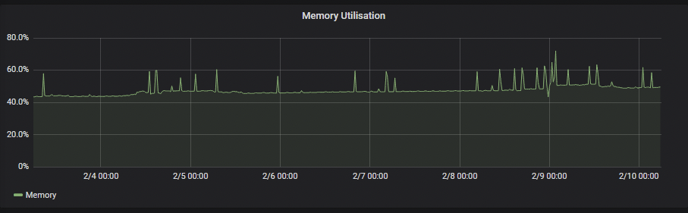

|  |  |
| --- | --- |
| Max Mem Peak Usage |  |
| Min Mem Usage |  |

#### $computeName2

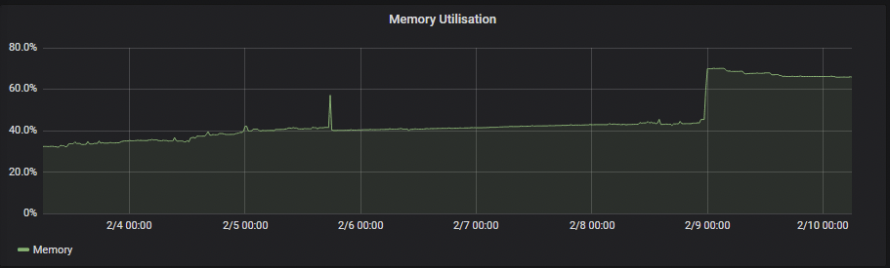

|  |  |
| --- | --- |
| Max Mem Peak Usage |  |
| Min Mem Usage |  |

#### 

#### $computeName3

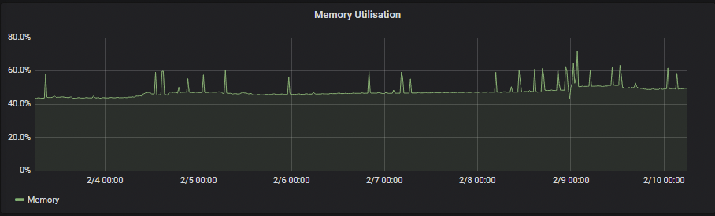

|  |  |
| --- | --- |
| Max Mem Peak Usage |  |
| Min Mem Usage |  |

# 

# Workload Analysis

## Objects Summary

|  |  |
| --- | --- |
| Number of projects | $projectsExcludingOCPSystem |
| Number of pod objects(Running) | $podObjects($podsRunning) |
| Number of deploy-type objects | $totalDeployObjects |
| Number of secrets | $totalSecrets |
| Number of ConfigMaps | $totalConfigMaps |
| Number of CronJobs | $totalCronJobs |
| Number of Jobs | $totalJobs |
| Number of DaemonSets | $totalDaemonSets |
| Number of ReplicaSet | $totalReplicaSet |
| Number of ReplicationController | $totaReplicationController |

#### Last week CPU Graph of project Usage

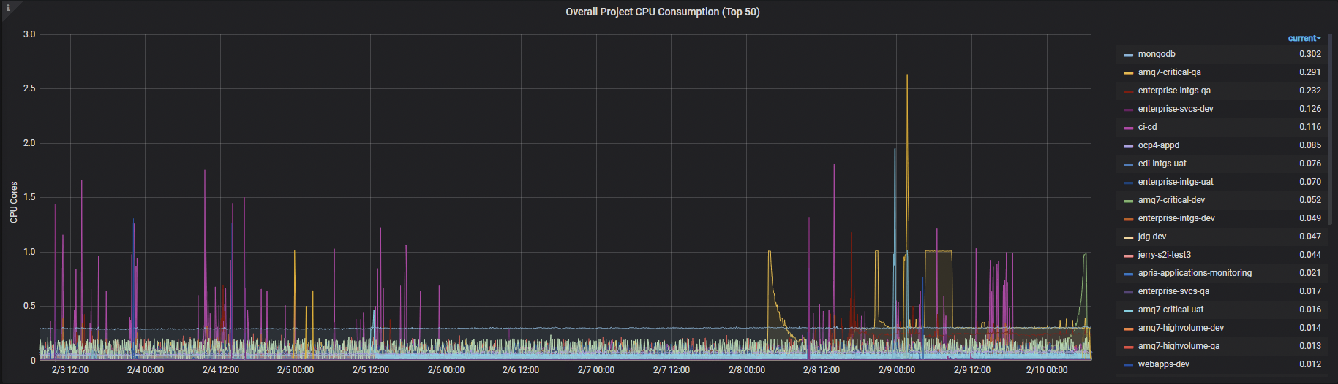

|  |  |
| --- | --- |
| Max CPU Usage by | $namespace ($namespaceTopCPUUsage) |
| $namespace cpu requests | $namespaceCpuRequest |
| $namespace mem requests | $namespaceMemRequest |
| $namespace cpu limits | $namespaceCpuLimit |
| $namespace mem limits | $namespaceMemLimit |

#### 

#### Last Week Mem Graph of project Usage

#### 

|  |  |
| --- | --- |
| Max Mem Usage by | $namespace($namespaceMemUsage) |
| Cpu usage by $namespace | $namespaceCpuUsage |
| $namespace cpu requests | $namespaceCpuRequest |
| $namespace cpu limits | $namespaceCpuLimit |
| $namespace mem requests | $namespaceMemRequest |
| $namespace mem limits | $namespaceMemLimit |

#### 

# Storage Analysis

## Summary

|  |  |
| --- | --- |
| Total PV | $totalPV |
| Total PVC | $totalPVC |
| StorageClasses | $totalSC |
| Object Buckets | $totalObjectBuckets |
| Object Buckets Claims | $totalObjectBucketsClaims |

## Summary of PV use cases

|  |  |
| --- | --- |
| RWO | $totalOfRWO |
| ROX | $totalOfROX |
| RWX | $totalOfRWX |

# 

# 

# 

# 

# 

# 

# Recent problems

No recent problems

# Recommendations and remediations

## $problemDetected1

## $ProblemDetected2

Possible solutions and recommendations to solve problem2

## $problemDetected3

Possible solutions and recommendations to solve problem3